**Program 10: 8-Queens Problem**

**Aim**

To write a Python program to solve the **8-Queens problem** using the **Backtracking algorithm**.

**Algorithm**

1. Define an N × N chessboard (for 8-Queens, N = 8).
2. Place queens one by one in different columns.
3. For each placement, check if the queen is safe (not attacked by any previously placed queen):
   * No other queen in the same row.
   * No other queen in the same column.
   * No other queen on diagonals.
4. If placement is valid, recursively place the next queen.
5. If no valid position exists, **backtrack** and move the previous queen.
6. Continue until all queens are placed.
7. Print the solution (board configuration).

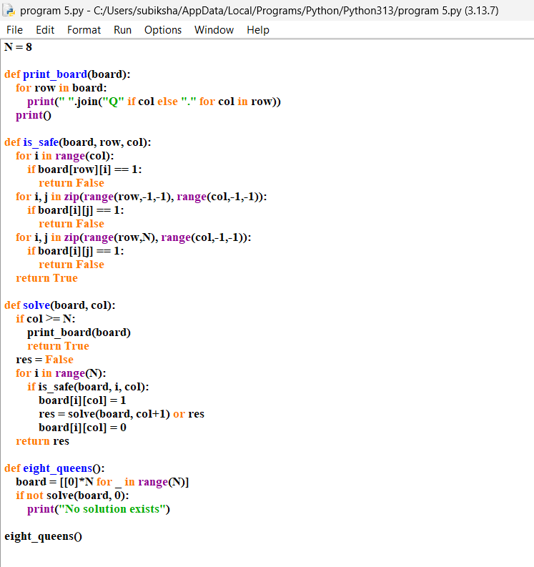

OUTPUT:

